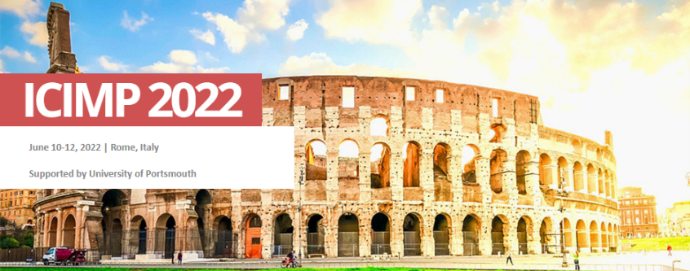
Registration Form
-listener

NOTE: To avoid delays in registration, please read the entire form carefully. Please submit your Filled Registration Form and Payment Proof of Applicable Registration Fee to icimp@chairmen.org before June 1, 2022.

Participant Information
*Registrant Name: |  |  | Male□ Female□
*Prefix: Professor/ Associate Professor/ Assistant Professor/ Lecturer/ Ph.D. Candidate/ Postgraduate/ etc... |  |  | *Participant’s Photo
*Affiliation:
*Research Area:
*Country: | *State/Province: | *City:
*E-mail:
Please send email to conference secretary if Invoice is needed. Provide below information in Chinese:
发票抬头：
统一社会信用代码：
明细内容（择一）： 如“会议费”、“会务费”、“会议服务费”、“会议注册费”
发票类型（择一）：电子发票、邮寄增值税普通发票、邮寄增值税专用发票（需更完整的信息）
International Receipt Title:

Special dietary:
Diabetic□ Vegetarian□ Halal□ Other□ (please specify: )

Conference Fees
Category | Early Bird Rate  (on or before Apr. 5, 2022) | Fee ( after Apr. 5, 2022)
Regular Listeners(On-site) | 230 USD |  | 260 USD
Student Listeners(On-site) | 200 USD |  | 230 USD
Regular Listeners(Online) | 180 USD
Student Listeners(Online) | 150 USD
Notice:
Authors / Listeners / Presenters Registration fees includes access to all meeting technical sessions; All participants will collect participation certificate, conference program, gift, and other materials on-site.

Payment Methods and Terms
- Credit Card (No handling fee)
http://confsys.iconf.org/online-payment/18130
Please calculate the right amount to pay. Please fill in the E-mail and Order ID after paying.
Enter the Total Amount You Paid:
Email Address of the Payment | Order ID

NOTE:
To avoid delays in registration, please read the entire form carefully and submit the following documents to icimp@chairmen.org
1. Registration Form (doc.)
2. The Scanned Payment of Applicable Registration Fee

Registration Cancellation Policy:
If the participants request cancellation and refund due to personal reasons, the following refund policy applies.
* 60 days ahead of the conference: 70% of payment refund
* 30-60 days ahead of the conference: 50% of payment refund
* Within 30 days ahead of the conference: no refund
Cancellation and refund request must be made formally via email. No shows will not be refunded. The Organizing Committees is not responsible for problems beyond our control such as weather conditions, campus conditions, travel difficulties, visa problems, health issues, etc.

* The organizing committees reserves the right to change the dates and place of the conference due to force majeure.
* The losses thus incurred from the force majeure events shall not be liabled and refunds policy shall not apply as well.

Security Precautions:
For the safety of your and others' personal and property, participants are required to wear name card, and those accompanying must wear the attendance card as well. Please keep the attendance card well. The conference leader onsite has the right to stop those without the attendance card from entering the meeting room.
Please note that the Organizing Committee will not accept liability for any kind of damage, losses or injuries occurring to persons or personal belongings during the conference. Be sure to organise suitable travel and health insurance.

Organizing Committee of ICIMP 2022
Rome, Italy

